How to install DDR2 SODIMM
怎样安装跟换内存条
like the same notebook memory installation method.
和笔记本的内存条安装方法一样。
Press and hold the memory, force down and Left and right ears forces, the memory can be taken down.
按住内存条，向下用力。并且向两边耳朵扣，内存条就可以取下来。
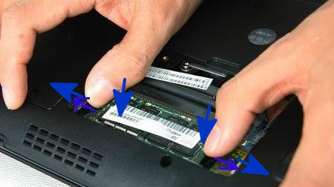
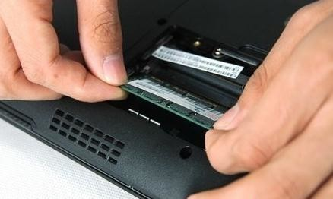
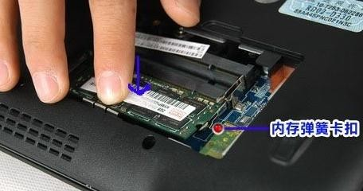
You can do it ?
学会了没有哦？

